**Name:** Chillara V L N S Pavana Vamsi

**Reg.no:** 21BCE5095

**Date:** 22/12/2022

**Faculty:** M Sivagami

## L21_L22_Lab1 Exercises

* 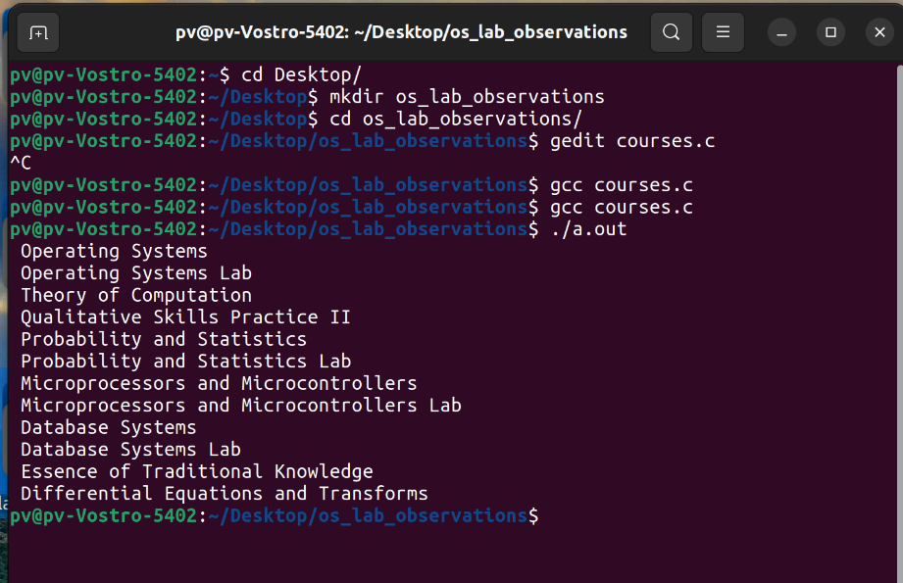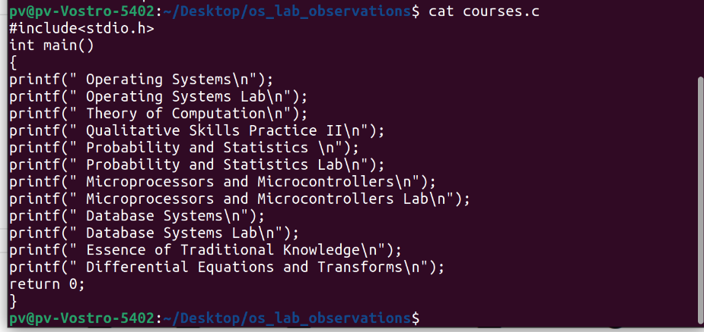**Develop a C Program to display the list of courses you have registered in this semester using only printf().**
* 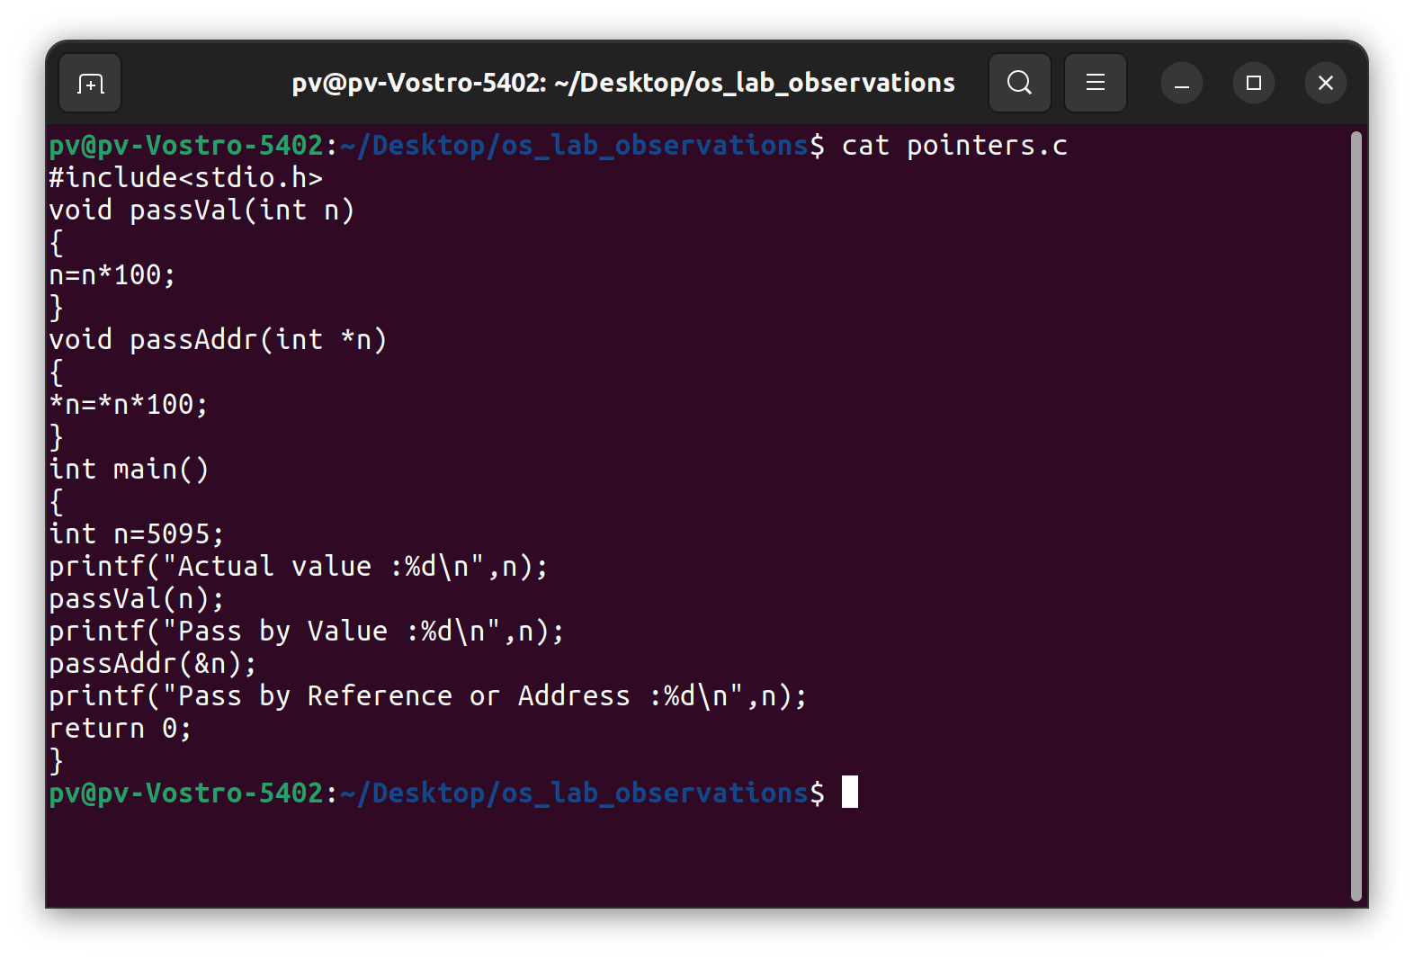**Develop a C program to show the difference between pass by reference and pass by value.**

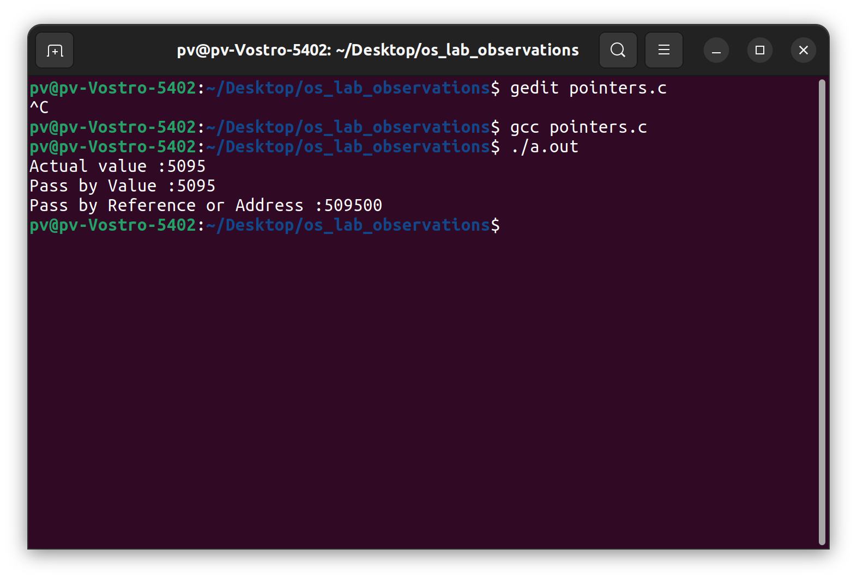

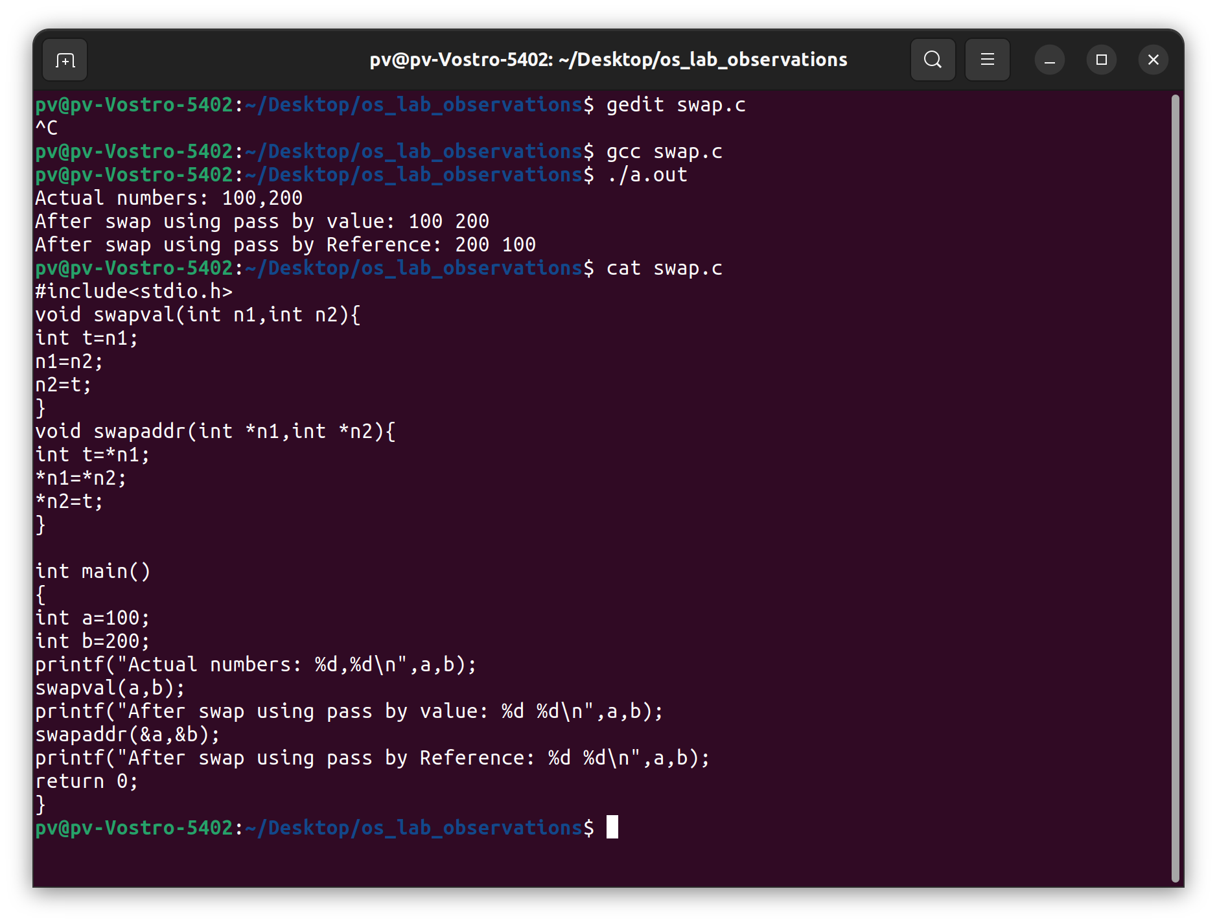

* Develop a C program to display the following using system() library function (through which you can run linux commands from c program)

(i) today's date

(ii) present working directory

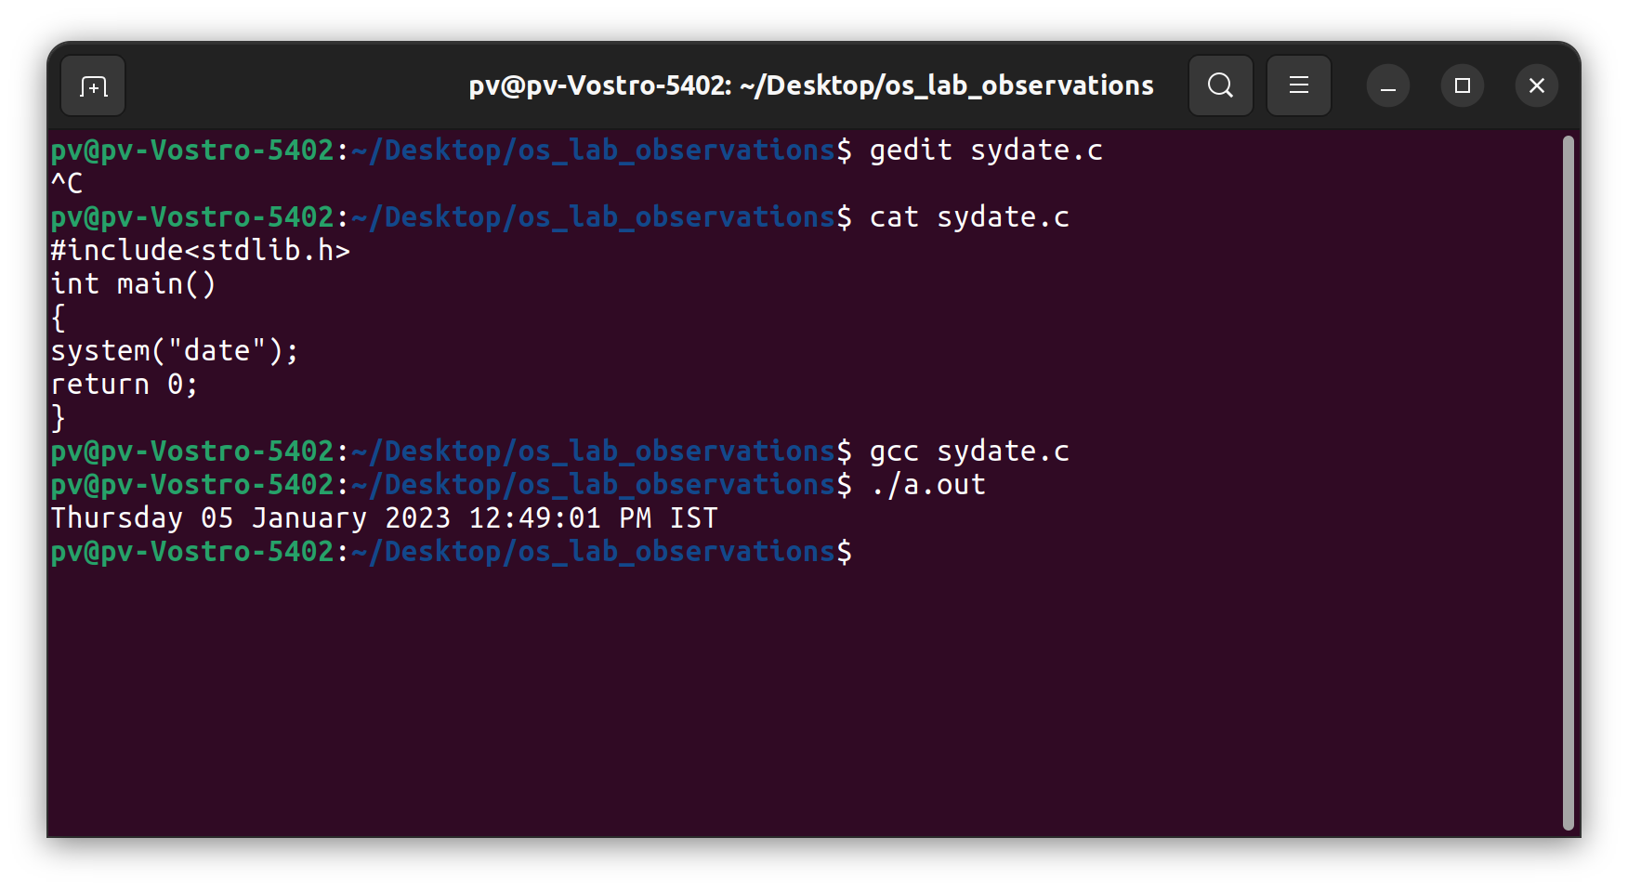

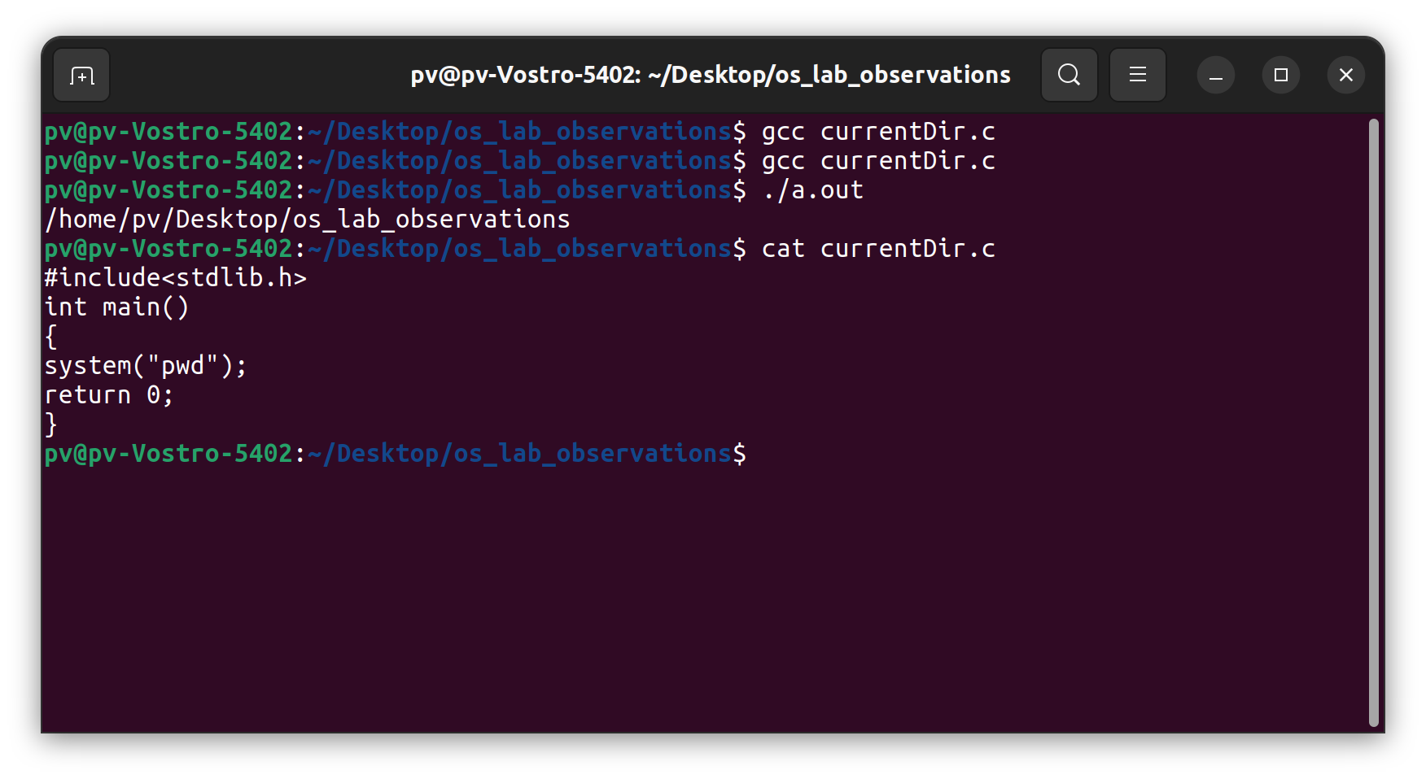

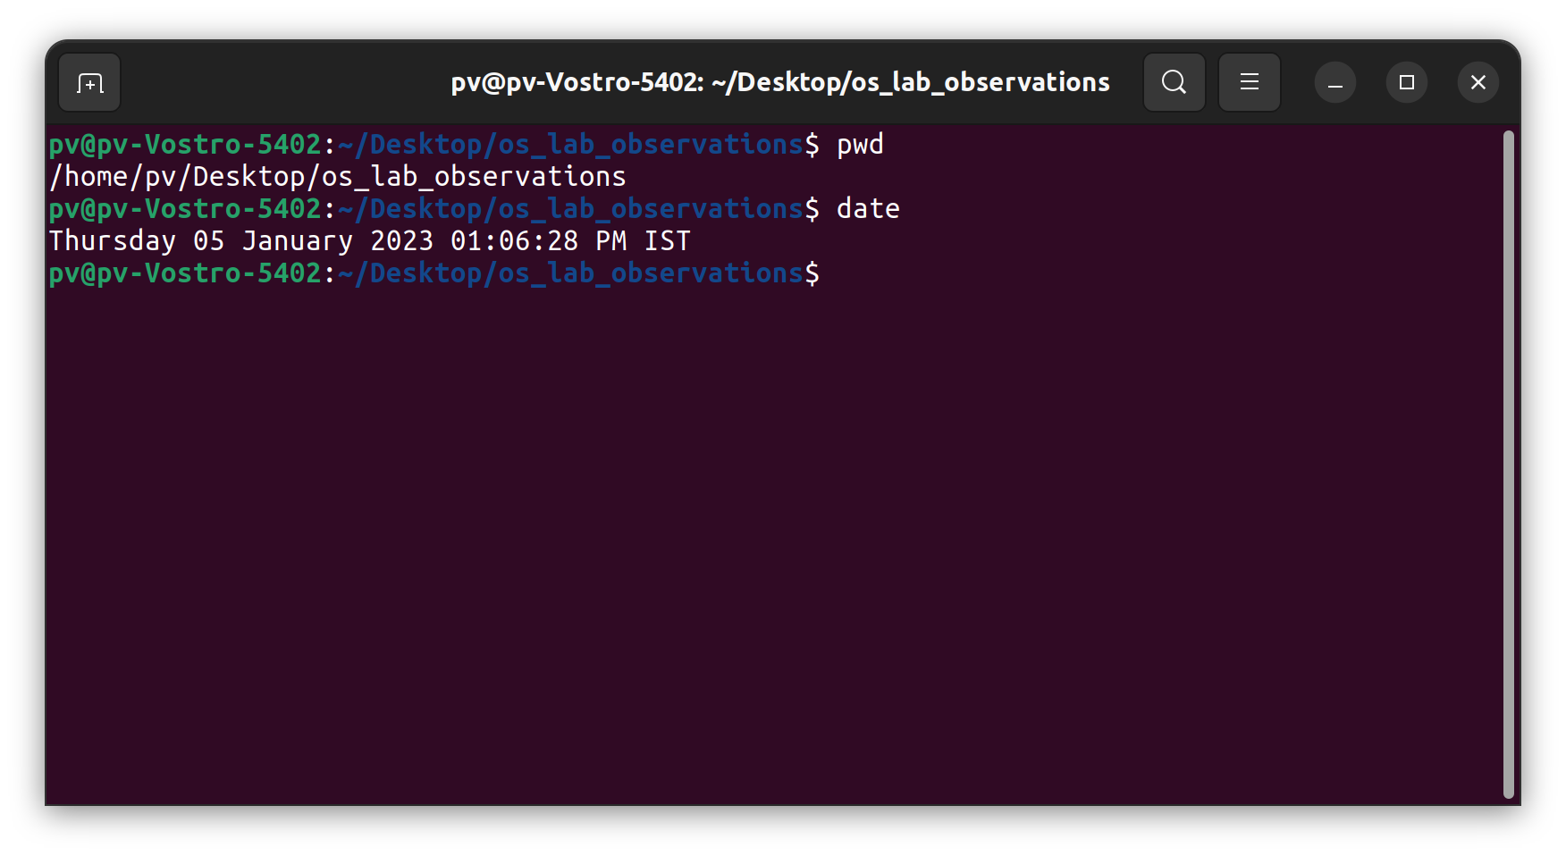

* 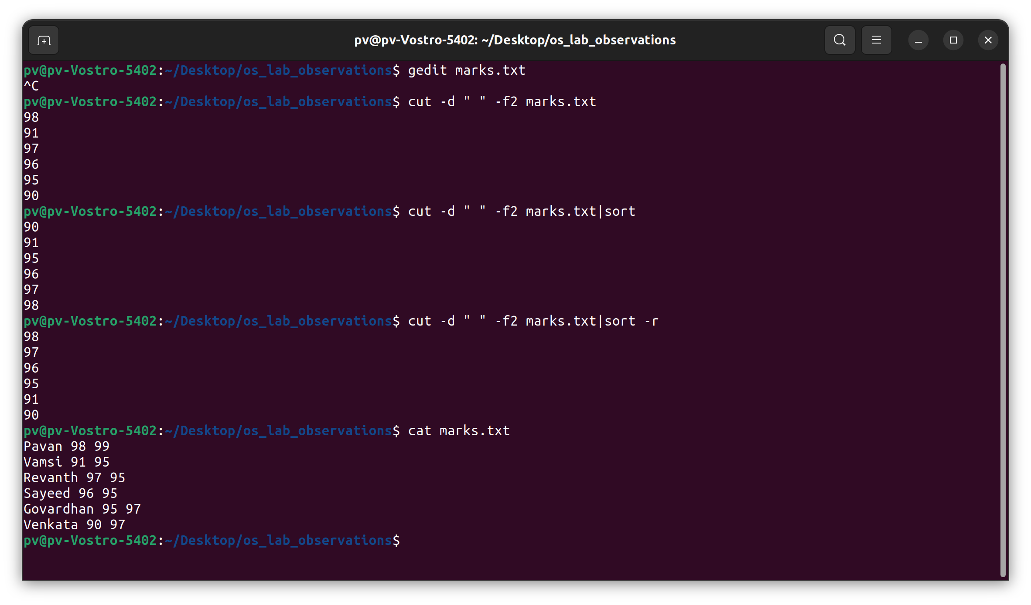Show the marks of CAT1 in sorting order from the marks.txt file using appropriate linux command

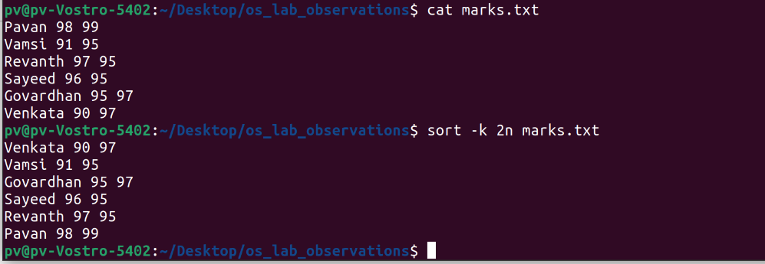

* Display the word count of the file using appropriate linux command

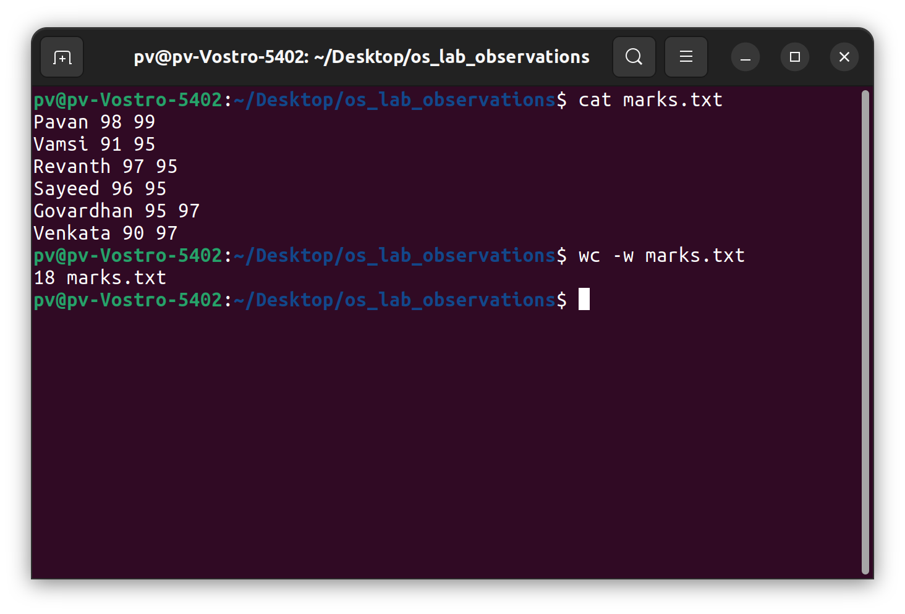

**Make a document of Linux commands of your choice of any 4 commands.**

|  |  |
| --- | --- |
| Command | Description |
| 1. man | * It is a command used as help * every time if we dont know how to use any command we can type man <command> |
| 1. ls | * Inside a folder you can list all the files that the folder contains using the ls command * ls |
| 1. cd | * Once you are in a folder using the cd command you can change your directory from that location * cd Desktop/ |
| 1. pwd | * It shows the directory where we are working at the moment * pwd |
| 1. mkdir | * You can create a folder using mkdir command * mkdir <folder name> |
| 1. rmdir | * You can remove a folder using rmdir command * rmdir <folder name> |
| 1. cat | * Using this command we can ceate files and add content to that file, append the content to that file * cat > file.txt   + creates the file and ask to enter the data required * cat >>file.txt   + to append the content * cat file.txt   + to view the content |
| 1. wc | * Word count |
| 1. Cut | * Cut option according to diffrent methods |
| 1. clear | * Clears all the working screen |
| 1. history | * It shows all the commands you used in the terminal from the start |